**Report to the Policymaker**

Effects of Policy Changes on Opioid Transactions and Mortality in the States of Florida, Texas and Washington

*Authors: Vishaal Venkatesh, Abhiraj Vinnakota, Roderick Whang*

1. **Abstract:**

2. **Motivation:**

Addiction to opioids is a very serious problem all around the world. What initially starts as simple cases of medically unjustified, overprescribing of painkilling opioids by physicians may quickly evolve to put millions of people at the risk of severe addiction ultimately leading to their deaths by overdose. While ostensibly it might seem that a simple change in policy to curb such rampant, careless prescriptions might be the solution to the problem – in reality, the situation is vastly more complicated. Substance abuse isn’t best treated by simply restricting access to drugs/opioids. Rehabilitation is often a carefully curated program where individuals are navigated through a series of phases to relieve them of their addictions. Simply curbing the supply of opioids might result in negative outcomes - which may include but not be limited to individuals seeking out illegal, more potent opioids. This may not only result in more serious addictions, but may also increase the chances of overdosing, as some of these illegally manufactured/circulated opioids such as heroin and fentanyl are far more potent than the average painkilling opioids such as oxycodone and hydrocodone. Moreover, such illegal transactions are not tracked by the Drug Enforcement Administration (DEA), which makes it impossible to accurately determine the magnitude of the problem. This strongly suggests that any piece of legislation aiming to regulate the flow opioids into a state must carefully consider the consequences. In this analysis, we aim to study the effects of policy changes on the per capita opioid transactions and opioid mortality in three different states where policy changes were made in the recent past – Florida, Texas and Washington state. We hope this analysis will serve the future policymaker well when it comes to enacting legislations regulating the flow of opioids.

3. **Data:**

There were three main sources of data that were used in this analysis.

3.1 **Opioid Transactions:**

The data on the county-wise transaction of drugs was obtained from the extensive database maintained by The Washington Post1. This dataset essentially tracks every opioid pill (hydrocodone or oxycodone) from the manufacturer to the pharmacy at a transaction (including the date on which the transaction occurred) level. Naturally, this dataset also included details on the location of the seller at the county level, date of transaction, volume of drug transaction, the Milligram Morphine Equivalent (a conversion factor based on the opioid Morphine), buyer location at the county level etc. Overall, this dataset was very comprehensive with data on over 180 million transactions between 2006-12 and was used to calculate per-capita opioid transactions in conjunction with the population dataset.

3.2 **Drug Overdoses:**

This is another comprehensive dataset maintained by the US Centers for Disease Control and Prevention (CDC) under its National Vital Statistics System2. This serves as a record for the number of deaths by county at a yearly level. The dataset also classifies death based on the cause of death. We are concerned only with the death caused due to drug overdoses to calculate mortality arising from drug overdoses. It also has to be noted that the dataset does not include the name of the exact drug involved in a death. Hence, this data is just a proxy to measure opioid related deaths.

* 1. **Population:**

This dataset contains data on the US population at a county level3. It has to be noted that the US census is taken once in ten years – with the last one being in 2010. The population for the year 2010 was the most relevant to this analysis as it was the closest to the years under consideration. We chose to use the population for 2010 for all the years under consideration as using rate of change of population assumes a linear rate of increase and may not be ideal for all the counties. This made using 2010 population data throughout, more reasonable.

The scope of the analyses on both the opioid transactions and the mortality arising from drug overdoses have been summarised in the following tables (Table 1 and Table 2).

|  |  |  |  |
| --- | --- | --- | --- |
| **State** | **Policy change year** | **Time period of analysis** | **Level** |
| Florida | 2010 | 2006 - 2012 | Yearly |

**Table 1.** Description of the scope of analysis for opioid transactions in Florida.

For the states of Texas and Washington, data was sparse at a yearly level. This is evident from us only having data for only 1 year post the year in which the policy was enforced. This makes analysis at a yearly level not very informative. Breaking this analysis down to the month level wasn’t very useful either as we were still capturing some yearly trends. Therefore, a simple percent increase/decrease in the per-capita opioid transactions of Texas and Washington were calculated and was compared with the average percent increase/decrease in the per-capita opioid transactions of all other (47 non-policy) states.

|  |  |  |  |
| --- | --- | --- | --- |
| **State** | **Policy change year** | **Time period of analysis** | **Method** |
| Texas | 2007 | 2006 - 2012 | Percent Increase |
| Washington | 2011 | 2006 - 2012 | Percent Increase |

**Table 2.** Description of the scope of analysis for opioid transactions in Texas and Washington.

|  |  |  |  |
| --- | --- | --- | --- |
| **State** | **Policy change year** | **Time period of analysis** | **Level** |
| Florida | 2010 | 2006 - 2014 | Yearly |
| Texas | 2007 | 2003 - 2011 | Yearly |
| Washington | 2011 | 2007 - 2015 | Yearly |

**Table 3.** Description of the scope of analysis for drug overdose mortality in Florida, Texas and Washington.

4. **Analysis and Interpretation:**

One approach to studying the effect of policy on per capita opioid transactions and drug overdose mortality is to simply look at the trends before and after the policy was enforced. If an *increasing* trend (positive slope) was observed in both per-capita opioid consumption and drug-related overdose deaths prior to the policy enactment – the lawmakers were well-justified in being alarmed and passing legislation to limit opioids flow into the state. Furthermore, if a *decreasing* trend (negative slope) was observed in both per-capita opioid consumption and drug-related overdose deaths post the policy enactment – the lawmakers were indeed very successful in circumventing a possible endemic that could have endangered millions of lives. The technical jargon for this type of analysis is known as a ‘Pre – Post Analysis’ and is often times very useful in gaining valuable insights into existing trends in the problem. However, this method is flawed in one major way and there are better methods to study the effects of policy change.

Let’s elucidate the flaw in the above method using an analogy. Consider the case of 17-year old Jeremy Belcher that lives in Princeton, New Jersey. Unfortunately, Jeremy is dangerously obese, and his physician has decided to enforce stringent measures to bring Jeremy’s weight down. For starters, Jeremy is only allowed a fluid-based diet (fruit juices, soups etc.) for a whole entire week. Jeremy has promised to stick to his new diet and is due to return in one week’s time so that the doctor may check on his progress.

A week later Jeremy visits his physician, and to everybody’s pleasant surprise Jeremy had lost 20 whole pounds! The doctor is pleased and deems his treatment a huge success. What the doctor did here is analogous to a simple pre – post analysis around his prescribed diet to Jeremy. What the doctor failed to realize was that Jeremy’s favorite chain burger-joints that he frequents was closed for renovations that week – all 49 branches. This may have been a huge, unaccounted factor in Jeremy’s progress. A simple pre – post analysis does not take such factors into account and can therefore be misleading. Instead of comparing Jeremy’s progress before and after a said treatment, a more effective form of analysis would be to compare Jeremy’s weight loss with that of another individual, say Ralph, who is comparable to Jeremy in terms of weight and also frequents the exact burger chain joints that Jeremy frequents. While this example might be getting unnecessarily specific to Jeremy and Princeton, New Jersey, parallels may be drawn between this analogy and the situation in Florida, Texas and Washington. While it is entirely possible that the change in policy was solely responsible for the decrease in opioid transactions and deaths, it could also very well be the case that a simultaneous federal curb on opioid flow – independent of policy changes at the state level- may have caused the desired results. This would inaccurately suggest that the policy change worked, while in reality it was a mere coincidence that a federal legislation was enacted at the same time as the state legislation. Analogous to comparing Jeremy with Ralph, a better technique in the case of states would be to compare the changes in, for e.g., Florida before and after policy change with another state similar to Florida before and after the policy change. Even better and statistically stronger is to compare Florida with all other 47 states where a policy was not enacted (All states excluding Washington, Texas and obviously Florida itself). This would eliminate the effects all the states were commonly subjected to at the time and help us isolate and study the effect of the policy on the policy state. In statistics, this technique is called the Difference-in-Difference method.

Following is an analysis of the opioid transactions and drug overdose mortality for each of the policy states - Florida, Washington and Texas.

**Pre-Post Comparison:**

With Pre-Post comparison, one of the most basic strategies, we compare how things were in policy states (TX, FL, WA) right before the policy in effective to policy states right after the policy in effective. In doing so, we can see whether the policy affect to reduce number of deaths caused by drug overdose and easily approach to causal inference.

In Texas, Pre-Post comparison shows that death rates by drug overdose kept increasing before the policy went into effect in 2007, then the rates have stayed in steady state since 2007.

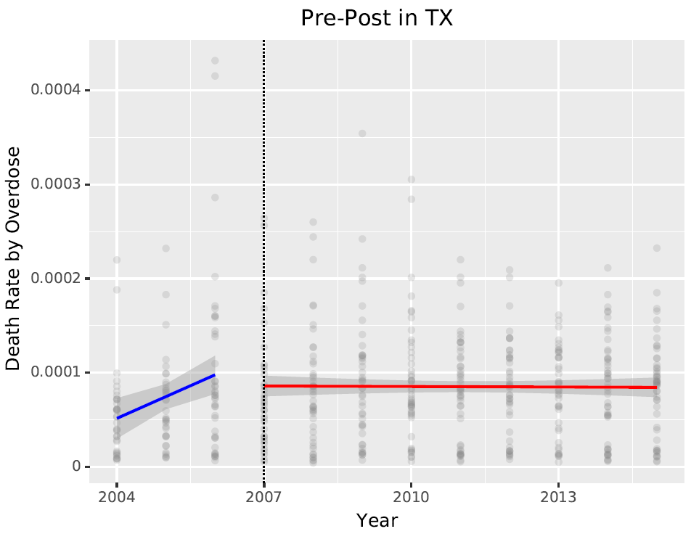

In Florida, as in Texas, death rates by drug overdose kept increasing before the policy went into effect in 2010, then the rates have been slightly decreasing since 2010.

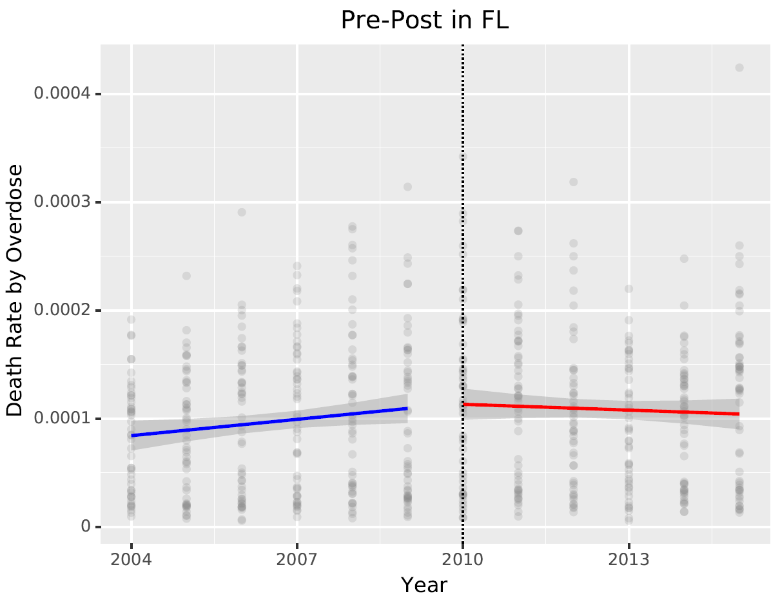

Different from Texas and Florida, In Washington state, the new policy seems not affect reducing death rates by drug overdose. It seems that the death rates are increasing gradually even after the policy in effective.

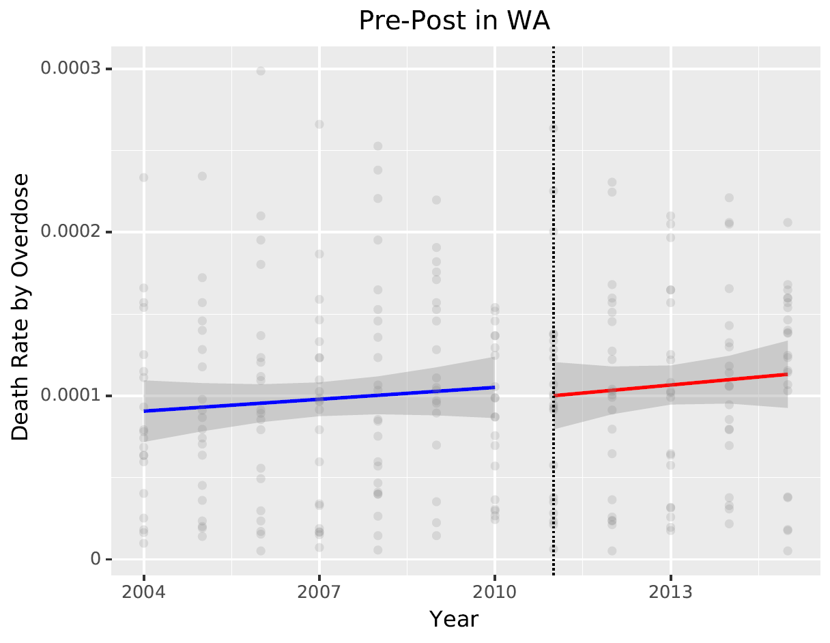

**Difference in Difference:**

In Difference in Difference, we don't just compare policy states before and after policy went into effect; instead, we compare with other states that didn't change their opioid policy. If policy in effect, then we would expect opioid overdoses in Florida to decrease differently than overdoses in states without a policy change We compared each policy state (TX, FL, WA) and non-policy states (47 states) with Difference in Difference comparison.

Before policy went into effect in Texas, the death rates by drug overdose of increase in Texas is faster than in other states without a policy change, then went into steady state after the policy in effective. However, the death rates in other states without a policy change continued to rise even after the policy in effective.

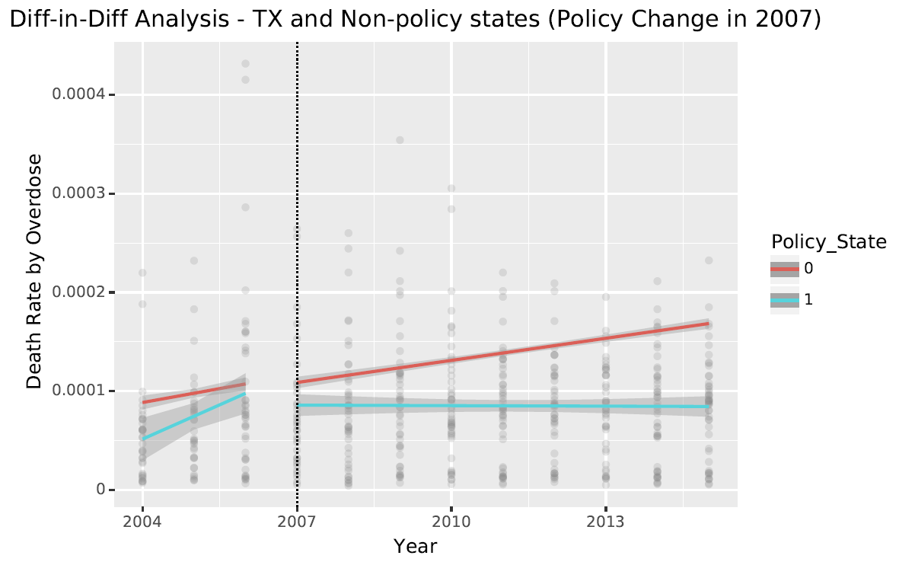

Difference-in-Difference analysis for Florida shows similar results from the case in Texas after policy went into effect. Death rates in Florida and other states show parallel trends prior to policy implementation before 2007.

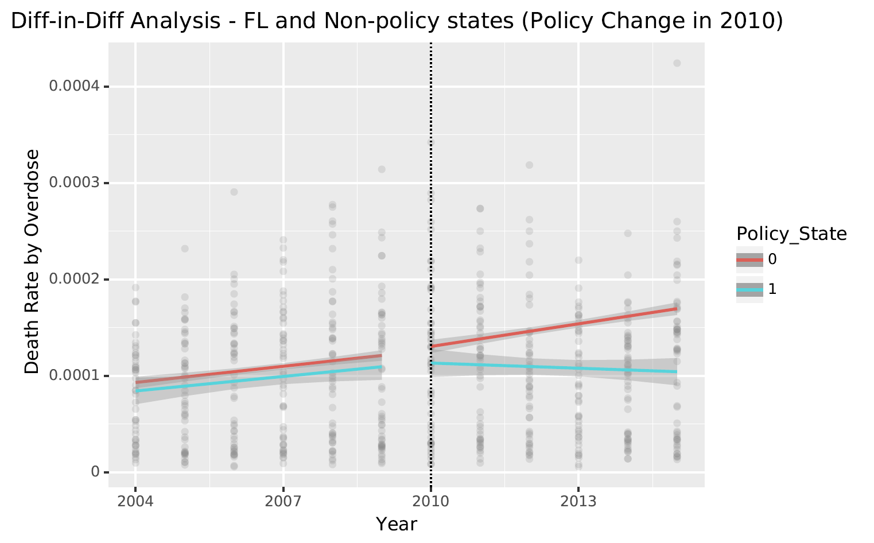

As mentioned in Pre-Post Analysis, Washington has little effect from policy changes as like the states without policy change.

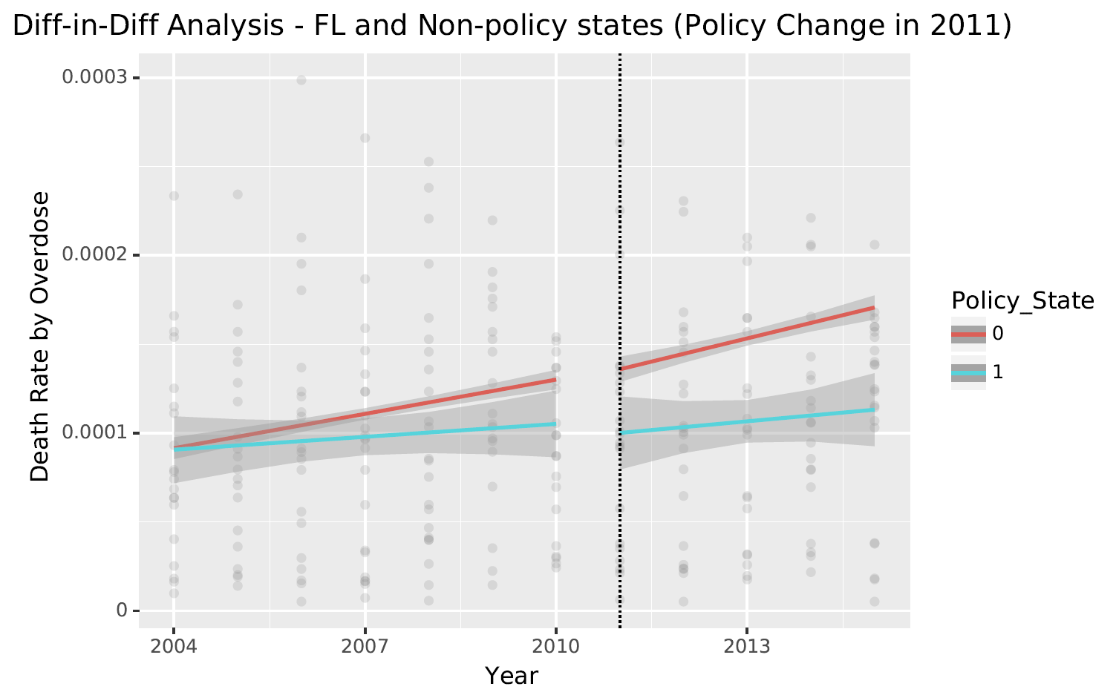

5**. Limitations:**

Although the overall analysis was quite satisfactory, there are a couple of limitations that have to be brought to the attention of the policymaker. Firstly, our data on opioid transactions only contain data on transactions – who sold it and who bought it. We don’t know if all the opioid transacted were dispensed – we have operated under the assumption that all the drugs transacted were sold and were sold in the same county where they were bought. Secondly, not all opioid transactions have to reported to the DEA. Only transactions exceeding a certain threshold have to be reported to the DEA as mandated by the law. This allows smaller transactions to escape the radar of the DEA and therefore making our analysis mostly accurate but not entirely accurate. Thirdly, the dataset on drug overdose mortality contains data on all-drug related deaths – not specifically deaths related to opioid overdosing. This makes our analysis suffer slightly as we have assumed all drug-related deaths to be caused due to opioid overdosing. Fourthly, the not drug-related deaths were reported in the drug overdose mortality dataset. Again, only deaths exceeding a certain threshold (10 deaths) were reported. Finally, insufficient data for Texas and Washington made it difficult to perform a thorough pre – post and difference in difference analysis. We had to resort to calculating percent-difference, which allowed us to gain an insight into the trends but were nevertheless a compromise.